FORM VALIDATION USING ANGULARJS

In this project we will add dynamic validation to our form using angularjs.

This is the basic html form.

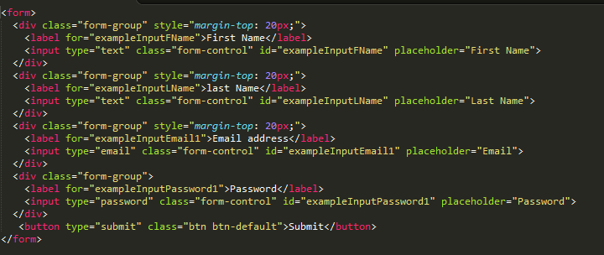

1) we need to add angularjs library to our form to use angularjs.

You can download it [here](https://angularjs.org/)

2)Include angularjs liberary <script src="lib/angular/angular.min.js"></script>

3)Add directive: Identify part of application that is controlled by angular js by adding ng-app directive to code.

4) Create a variable inside ng-app. To create this variable we will use ng-model directive and assign it a name.

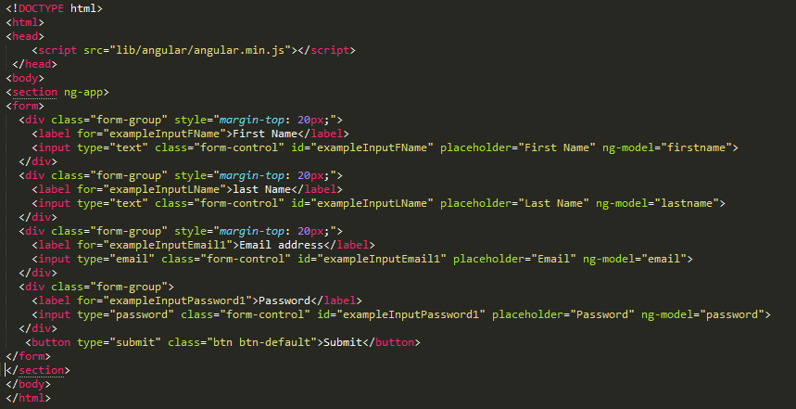.

Now we have created number of variables that are accessible within the scope of ng-app.

We can also place the whole thing inside an object by using

ng-model = user.firstname

So that all these models are within the same object.

So all these things will go into a global set of user object.

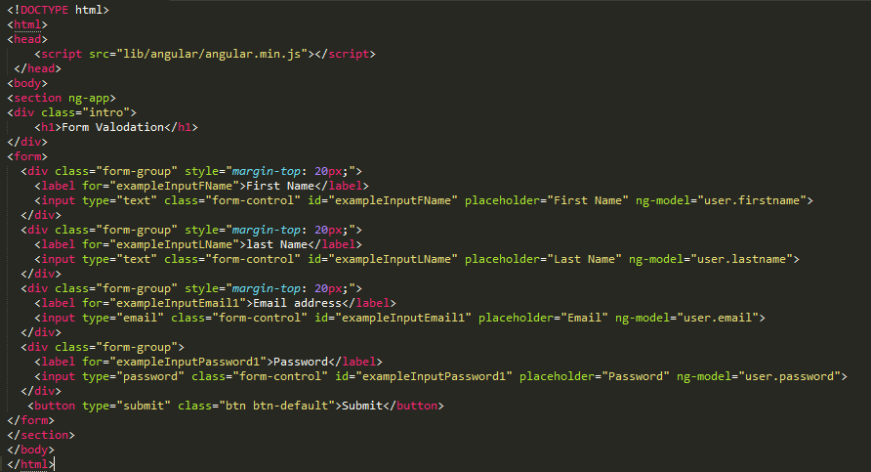

Browser have some default validation we do not want to use that so that we can use angular js validation attributes and properties.

1) Add novalidate as attribute

2) Attributes for fields:

ng-required

ng-minlength

ng-maxlength

ng-pattern

As we add different input types angular will generate a series of properties for each of the models

Properties/Classes

$pristine

$dirty

$touched

$valid

$invalid

Now add ng-required=”true” to form element

And to show error message add:

<p ng-show></p>

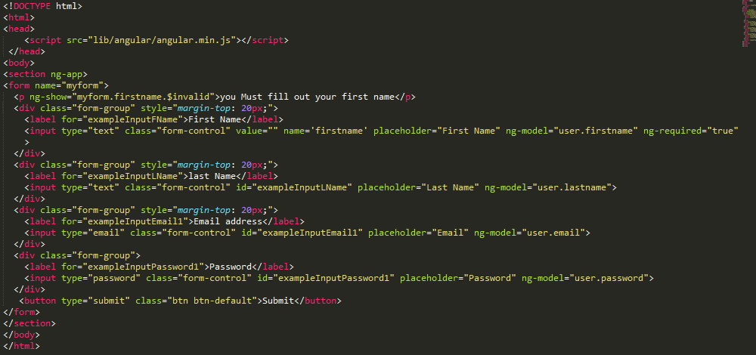

The problem with above code is the error message shows up even when form loads.

So adding another attribute to remove error message is to check weather form element has been touched or not.

Check out : github for detail

s